Embracing a Low-Carbon Future for Nigeria: The Paris Agreement.

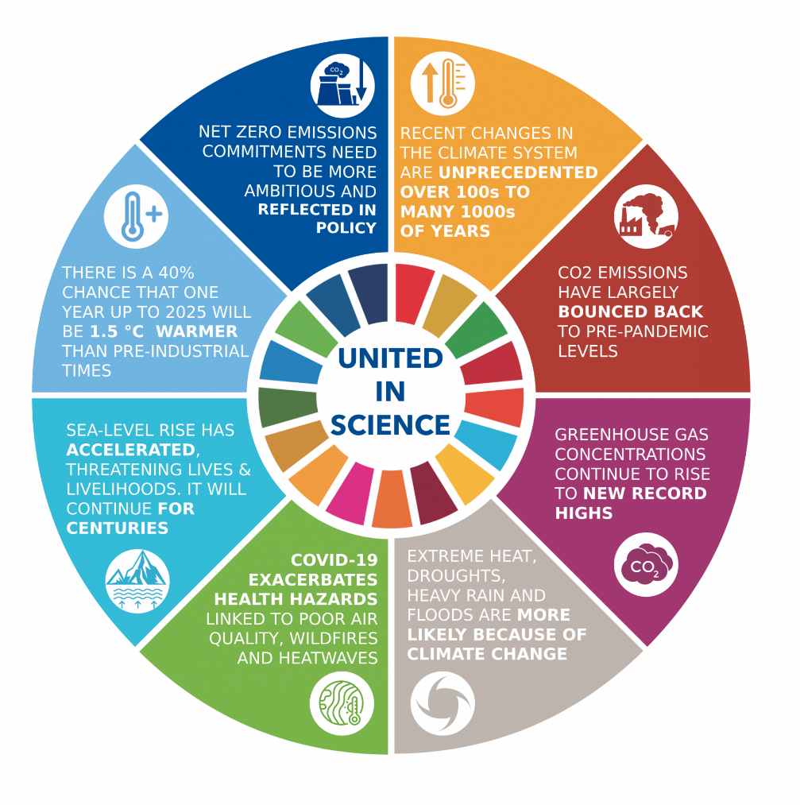

The latest ever-increasing average global earth temperature as recorded by the National Aeronautics and Space Administration (NASA ) hit 1.17 °C in 2023, surpassing the global threshold at 1.5°C above the pre-industrial era.

Global warming is caused by the emission of gases that hinder the dispersion of ground heat into outer space. These gases propelled by human activity include water vapor, carbon dioxide, methane, nitrous oxide, and chlorofluorocarbons (CFCs). This phenomenon is generally known as greenhouse gases and the effect thereof is global warming hence, climate change.

However, since pre-industrialization, the birth of the oil and gas industry, and the augmented consumption of fossil fuels, the emission of carbon dioxide has been a major contributor to world heat.

## Understanding Low Carbon?

The concept of low carbon revolves around reducing the amount of carbon dioxide (CO2) emissions released into the atmosphere. Carbon dioxide is a greenhouse gas that contributes to global warming and climate change when emitted in large quantities.

It comes from various natural and human activities. Some primary sources of CO2 include natural processes such as respiration by animals and plants, volcanic eruptions, and decomposition of organic matter.

The combustion of fossil fuels such as coal, oil, and natural gas for energy production in power plants, transportation, industrial processes, and residential heating releases significant amounts of CO2 into the atmosphere.

According to the United Nations, “deforestation and forest degradation accounts for 11% of carbon emissions”. When forests are cleared or burned, the stored ./carbon in trees is released as CO2, contributing to increased atmospheric concentrations of the gas.

In the same vein, certain industrial activities, such as cement production, chemical manufacturing, and metal smelting, contribute to the emission of CO2 into the atmosphere as a byproduct.

Other minor practices include agricultural activities such as livestock farming and rice cultivation that produce CO2 through enteric fermentation in animals and decomposition of organic matter in the soil respectively. These sources collectively contribute to the carbon dioxide emissions that are driving climate change and global warming today.

In recent years, the urgency of addressing climate change has become increasingly evident. With rising global temperatures, extreme weather conditions, and environmental degradation, the need for action has never been more pressing.

Sequel to this, one key solution that has gained traction in the fight against climate change is the adoption of low-carbon practices by transitioning to technologies and lifestyles that accommodate reduced emission of CO2.

This by extension is the driving motive towards the Paris Agreement. The initiative is aimed at maintaining the global temperature at 1.5°C above the pre-industrial era.

Fig 2: From the footage below, we can see the pictorial difference in the earth’s atmosphere dating from 1884 to 2022 due to global warming.

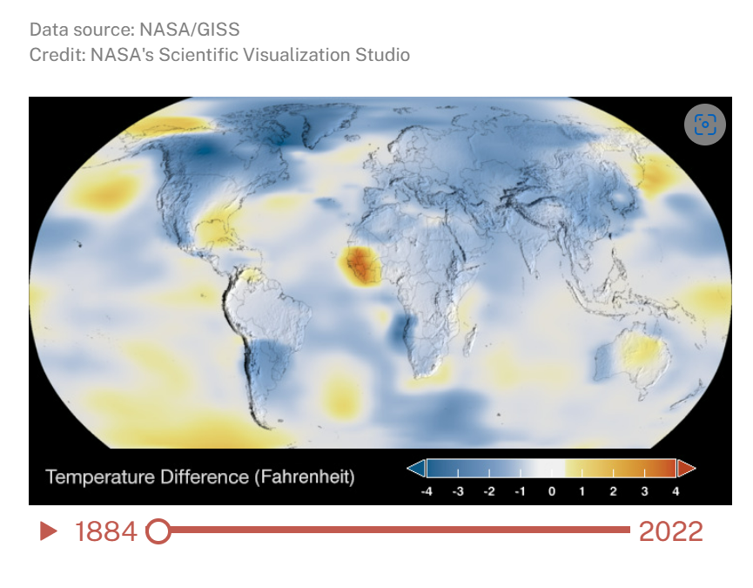

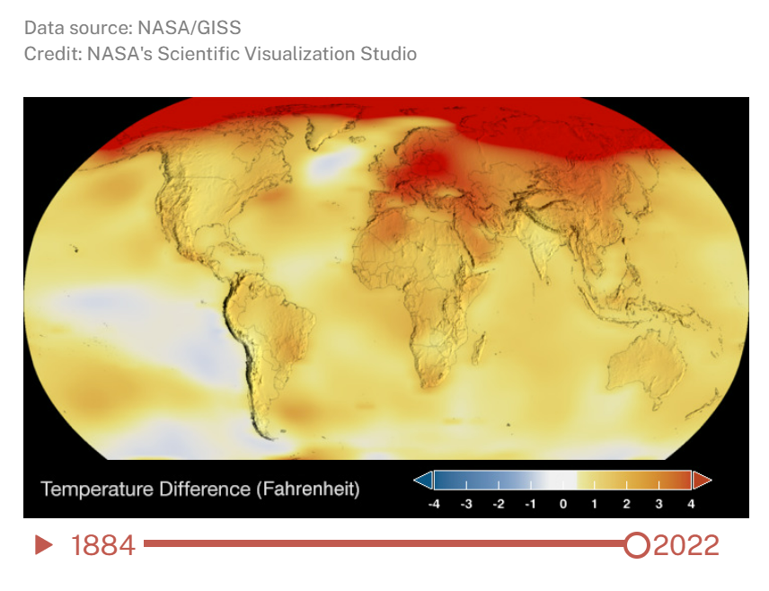

This is a clear indication of the near doom of our planet and the height in the climate crisis globally.

This is also an indirect analysis of the changes experienced in the climate sphere in Nigeria.

For instance, due to high carbon emissions and other factors that affect the climate, The Nigerian Metrological Agency (NIMET) has revealed in its 2024 seasonal climate prediction the looming disaster of drought and heavy flooding in states like Port Harcourt, Kogi, Niger, Anambra, and Benue.

This is one of the reasons why maintaining our Nationally Determined Contribution towards achieving the goal of the Paris Agreement is crucial.

## Nigeria and The Paris Agreement

The Paris Agreement is a global treaty that is geared towards reducing the earth’s global temperature to 1.5 degrees Celsius above the pre-industrial era by 2030.

Sequel to this, Sustainable Development Goal (SDGs) are deliberate in design to also achieve this broader objective for climate consideration. SDG 13 (Climate Action) and the other goals that constitute the environmental pillars (SDG 6- Clean water, 7- Affordable and clean Energy, 12- Responsible consumption and production, 14- Life below water, and 15- Life on land) are all averse to the need for urgent attention with a focus on low carbon emissions.

The Paris Agreement is held together by Nationally Determined Contributions defined and developed by individual countries and supported by various frameworks.

During COP26, Nigeria committed to achieve net-zero by 2060, and barely a week after the conference, President Muhammadu Buhari signed into law the Climate Change Act, 20211(the Act), which was passed by the National Assembly in October 2021.

The Act requires all ministries, departments and agencies (MDAs) of the Federal Government; and public and private enterprises in Nigeria to develop and implement mechanisms geared towards fostering low carbon emission, environmentally sustainable, and a climate resilient society.

Nigeria’s NDC has an unconditional target to reduce emissions by 20% by 2030 and a conditional target of between 40% to 47%. Other supporting targets include energy efficiency, climate-smart agriculture, and clean cooking amongst others.

The agreement allows voluntary contribution which gives room for host countries to broaden their ambition to ensure a safe climate environment.

There are several frameworks within the Paris Agreement to which Nigeria is signed, which when implemented will position the country and subnational to unlock climate financing. Example is the Article 6 Framework. This framework embodies

## Article 6 framework…………

Avenues through which we can utilize this framework through host country carbon market transactions, through the provision of the Paris Agreement include the following;

**Energy:**

Transitioning to renewable energy sources such as solar, wind, hydropower, and biomass can help reduce reliance on fossil fuels and decrease emissions from the energy sector. This is an avenue through which we can update our energy sector to current practices as well as achieve the goals of the agreement.

Improving energy efficiency in industries, buildings, and transportation can also contribute to emission reductions and promote sustainable energy use.

**Agricultural Sector**: Engaging in smart agricultural practices such as conservation agriculture helps sequester carbon in the soil and reduces the need for tillage, which can release carbon stored in the soil. Agroforestry is another method. Trees act as carbon sinks, absorbing CO2 from the atmosphere and storing it in their biomass and soil. Adoption of renewable energy sources such as solar, wind, and biogas for farm energy needs can reduce reliance on fossil fuels and associated carbon emissions.

**Waste Management:**

Implementing waste reduction, recycling, and composting programs can help reduce methane emissions from landfills and promote resource efficiency.

Investing in waste-to-energy technologies, promoting organic waste management, and implementing policies to reduce plastic pollution can also contribute to emission reductions and environmental sustainability.

**Water Sanitation**: Utilizing the benefits of carbon market transactions can translate into investing in water efficiency technologies that can help reduce energy consumption and emissions associated with water supply and treatment.

There are so many options we can explore as a country to achieve these desired goals.

For Nigeria, embracing the Paris Agreement offers numerous benefits across various sectors of the economy and society including economic opportunities, energy security, climate resilience, international cooperation and aligning climate action with the Sustainable Development Goals (SDGs)

The Nigeria Governors Forum is a major advocate for the SDGs and thus explains our involvement in securing a future for Nigeria in the carbon market space. The SDG/Climate change desk has actively participated in several climate change workshops with the aim of securing subnational interest and readiness to participate in the carbon market.

NGF also has provided the states with guidance tools such as the National Climate Change Policy template to help plan and prepare State’s climate informed budgets for analysis, reporting and expenditure monitoring and tracking climate performance. Potential entry points for mainstreaming climate change in the budget process include the following: Capacity building exercise, Strategic planning level, National development plans and Legislation.

The NGF collaborated with the Department of Climate Change (Federal Ministry of Environment) and the Society for Planet Prosperity to produce the very first subnational report on Climate change which focused on citizen awareness, climate policy and climate action at the subnational level.

…….

The Paris Agreement stands as a beacon of hope in the global fight against climate change, offering a pathway towards a sustainable, low-carbon future for nations worldwide. In the case of Nigeria, a country rich in natural resources but facing significant environmental challenges, the Paris Agreement presents a unique opportunity to chart a course towards a greener, more resilient future.

In conclusion, Nigeria's commitment to the Paris Agreement signifies a recognition of the urgent need to address climate change and its impact on the country's economy, society, and environment. By pledging to reduce greenhouse gas emissions and enhance climate resilience, Nigeria has taken a significant step towards aligning its national and subnational priorities with the global communities’ effort to combat climate change. Implementing the pledge will unlock access to climate financing for development.