**REPORT OF A 2-DAY COORDINATION REVIEW AND VALIDATION MEETING OF INTEGRATED STATE STRATEGIC PLAN OF ACTION FOR NUTRITION AND REVIEW OF STATE POLICY ON FOOD AND NUTRITION FROM 5TH TO 6TH MAY, 2021 AT LAND MARK HOTELS, D LINE, PORT HARCOURT, RIVERS STATE.**

**OPENING FORMALITIES:**

The meeting was called to order by the Director of Planning, Implementation and International Corporation Mrs. Ephraim -George Imaonyani of Ministry of Budget & Economic Planning. An opening prayer was said by Mr. Buduzhi Gift Oguzor of Rivers State Primary Health Care Management Board and State Committee on Food and Nutrition (SCFN) Secretary at about 11:10am. Subsequently, was introduction of dignitaries that attended the meeting as well participants and facilitators? The meeting had participants and dignitaries from relevant MDA’s especially Ministry of Agriculture, Ministry of Health, Ministry of Women Affairs, Ministry of Social Welfare and Rehabilitation and Ministry of Budget and Economic Planning. Others were from Ministry of Justice, Ministry of Education, Ministry of Water Resources, Rivers State Universal Basic Education Board and Rivers State Primary Health Care Management Board, RUWASA, Rivers State University- Food Science & Technology Department and Civil Society Scaling Up Nutrition (CS-SUNN). The resource persons were Prof. Alice Nte of University of Port Harcourt Teaching Hospital and Prof. Kola Matthew Anigo of Ahmadu Bello University Zaria including Mrs. Ngozi Onoura from UNICEF.

Mrs. Ephraim -George Imaonyani further gave a background of SCFN and the essence of the calibre of participants been invited to the meeting. She noted that though some of the persons that started the costing of the strategic plan of action during a 5 day meeting in 2017 at Ayalla Hotel’s, Yenagoa, Bayelsa State were not present. She attributed their absence to retirement or deployment or appointment into new offices. She further noted that some MDA’s did not nominate senior management personnel to make meaningful contribution nor take decision concerning their ministry during the Bayelsa meeting. Notably, she mentioned Ministry of Social Welfare & Rehabilitation and Ministry of Women Affairs. She also referenced a December 2019 coordination meeting hosted by Civil Society Scaling Up Nutrition (CS-SUNN) where MDA’s were mandated to populate their sectoral plan but regretted the inabilities of MDA’s in performing their responsibility. She concluded her remarks by expressing optimism with the zeal the participants have and lessons learnt over the years, the state shall achieve the objective of the meeting.

The Chairman State Committee on Food and Nutrition (SCFN) and Permanent Secretary Ministry of Budget and Economic Planning Mrs. Titilola Cline in her remarks welcomed all participants to the workshop. She noted that the meeting is strategic for a number of reasons. Firstly, that posterity shall beckon on us as contributors towards the conclusion of the state strategic plan of action for nutrition. She equally expressed optimism that since the template had been earlier forwarded to the MDA’s, it would be easier to update during the period of the meeting/workshop. She expressed hope that Honourable Commissioner of Finance and Supervising Commissioner of Ministry of Budget and Economic Planning Hon. Isaac Kamalu shall give accelerated speed towards approval to the State Strategic Plan of Action for Nutrition (SSPAN) document when presented to him, because he understand the importance of food and nutrition towards national development.

While she emphasized the cost and logistics for the hosting of the meeting, she urged participants to concentrate and put in their best to achieve the goal of the meeting. She also commended Mrs. Ngozi Onoura UNICEF Nutrition Specialist for her untiring efforts towards achieving notable landmarks in Rivers State nutrition programme. She equally appreciated her colleagues Permanent Secretaries and facilitators.

Subsequently, the objectives and expected outcomes of the workshop were presented by the Secretary of SCFN Mr. Buduzhi Gift Oguzor.

**Objectives/Expected Outcomes**: The objectives and expected outcomes of the workshop as presented by the State Nutrition Officer Rivers State Primary Health Care Management Board and Secretary State Committee on Food and Nutrition (SCFN) Mr. Buduzhi Gift Oguzor includes:

1. To review the state strategic plan of action for nutrition 2018-2021

2. To update the state strategic plan of action for nutrition 2021-2025

3. To validate the state strategic plan of action for nutrition 2021-2025

4. To review the state policy on food and nutrition

5. To take decision on next line of action after the meeting

The expected outcome includes:

1. That at the end of the meeting the state would have produced a validated costed state specific strategic plan of action for nutrition 2021-2025.
2. To have a reviewed policy on food and nutrition.

**Goodwill Message**: Good will messages were received from Mrs. Ngozi Onuora UNICEF Nutrition Specialist, Prof Alice Nte of UPTH, Prof Kola Matthew Anigo and Mrs. Obiagili Ezegwu CS-SUNN State Coordinator. They all expressed willingness to support the Rivers State Committee on Food and Nutrition. They equally urged all MDA’s to take responsibility and ensure we achieve the expected result.

**TECHNICAL PRESENTATION:**

The first presentation on review of costed of Rivers State strategic plan of action for nutrition was anchored by Prof. Kola. M. Anigo, of Ahmadu Bello University of Zaria. His presentation defined terminologies such as strategy of the plan, direction on course of action to achieve intended goals, and how to achieve them. His also presentation showed why strategic, such as ways to focus and figure out how things are to be done while taking advantage of resources and emerging opportunities. He also explained that strategic plan should include set priorities and the need to focus energy and resources on common goals and results and how to communicate such goals and actions needed to achieve them. His slide equally emphasizes the need for every sector to see their work reflected in focus areas and how they can contribute to the mission. The presentation showed the need for target population especially vulnerable including women and children, indictors, and plans for behaviour change communication. Others were advocacy, partnership, capacity building, and research, monitoring and evaluation. He also explained implication of the plan such that, considering the burden, potential for impact, resource requirement and capacity for implementation. His presentation also highlighted cost and benefits of scaling up key investments and her intentions to guide policy makers in future plan against malnutrition in the state.

His presentation further showed what the costed plan entails, example the result areas, expected outcome, total cost for result areas, interventions narrative, indicators, frequency and the years the plan covers. The presentation hinged on six priority areas namely; food and nutrition security, enhancing care giving capacity, enhancing the provision of quality health services, improving capacity to address food and nutrition security, raising awareness and understanding of the problems of malnutrition and resource allocation for food and nutrition security at all levels. His slide also showed that objective should be SMART meaning-specific, measurable, achievable, realizable and time bound. He also dwells on monitoring, evaluation, accountability, and learning (MEAL), costing, the template to populate, collations analysis. He further divided the participants into 4 groups to work as below;

Agriculture- Result area 1 (Food and Nutrition Security)-Sector Agriculture

Nutrition & Health –Result area 2 and 3 (2. Enhancing Care giving Capacity 3. Enhancing Provision of Quality Health Services)-Sector Health –RSPHCMB, RSMOH & CS-SUNN.

Education, Social Protection and WAH-Result areas 1 and 5 (1. Food and Nutrition Security 5. Raising Awareness and understanding of problems of malnutrition in Nigeria) –Sector Education, Social Protection, Women Affairs, Justice, WASH & Academia)

Planning, M & E, Research and Financing-Result areas 4 and 6 (4. Improving Capacity to Address Food and Nutrition Insecurity 6. Resource Allocation for Food and Nutrition Security at all Levels). Sector- Ministry of Budget & Economic Planning.

He concluded his presentation by advancing the need for an innovative approach to nutrition costing to strengthen nutritional outcome in the state by implementing low cost with high impact interventions.

**Group Presentation:** Each sector made presentation at the end of the group work whereas; contributions were made by both participants and facilitations. Each sector was mandated to make necessary corrections in their validated coated plans in line with the objectives of the workshop and submit same to the secretary which was compiled with.

**QUESTION AND ANSWER**:

Question and answer sessions were observed whereas participant’s questions were adequately addressed.

**ACTION POINTS:**

Participants in session agreed on the followings;

Formations of a committee to fine tune the state strategic of plan of action for nutrition. The committee membership is as listed below:

1. Mrs. Titilola K. Cline (MBEP) -Chairman
2. Mrs. Imaonyani Ephraim- George (MBEP)
3. Mrs. A. G. Saloka (MBEP)
4. Dr. Julienne Darlington-Nwoke (RSMOH) -Secretary
5. Barr. Chijioke Boms (MOJ)
6. Mrs. Orisa Catherine Achese (RISU)
7. Mr. Buduzhi Gift Oguzor (RSPHCMB)

Specifically, editing of the old draft of the state specific strategic plan of action for nutrition 2021-2025 was handled by Mrs. Orisa Catherine Achese and Mr. Buduzhi Gift Oguzor, while, the state policy on food and nutrition document is been edited by Prof Alice Nte of UPTH, Port Harcourt.

**WAY FOWARD:**

As a follow up to the compilation of various MDA’s sectoral plan, a meeting of the committee was scheduled to hold on Monday 10th May, 2021 by 10:00am at Room 25, Block B, State Secretariat Complex, Ministry of Budget and Economic Planning.

**WRAP UP:**

A vote of thanks was rendered by Mrs. Titilola Cline Permanent Secretary and Chairman of SCFN on behalf of the State. She commended participants for their, patience, resilience and efforts in updating their sectoral plan. She also appreciated UNICEF for sponsorship of the meeting. Finally, she thanked the facilitators for the zeal towards ensuring that the state strategic plan of action for nutrition document is actualized. A closing prayer was offered by Mrs. Uzoma of the Ministry of Budget and Economic Planning.

**Mr. Buduzhi Gift Oguzor**

**Secretary State Committee on Food and Nutrition &**

**Nutrition Officer Rivers State Primary Health Care Management Board**

**ANNEX 1 –Cover page**



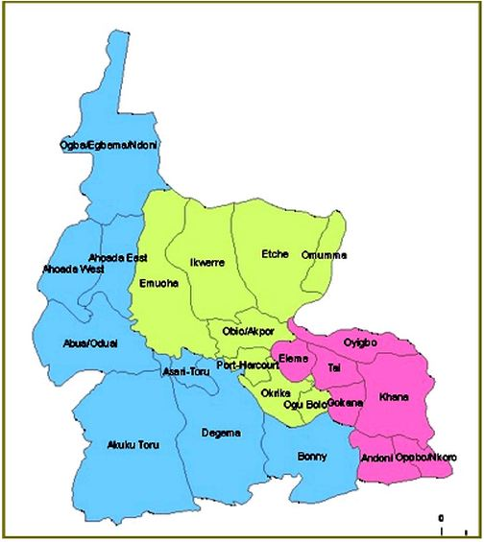

RIVERS STATE MULTISECTORAL PLAN OF ACTION FOR FOOD AND NUTRITION

2021 - 2025

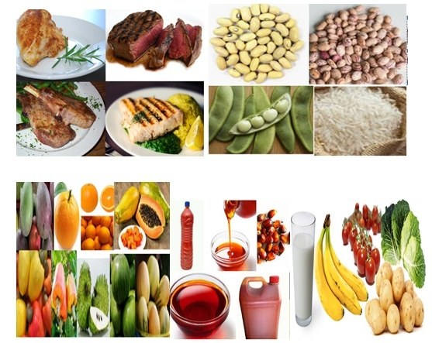

**Sponsored by: UNICEF **