Guidance Pack 2013–15
Part 2: Toolkit

Stage 1: Corporate Planning

Process: Preparation

1a. Briefing Note on

Corporate Planning
June 2014

1a Briefing Note on Corporate Planning

Background
International best practice shows that an essential prerequisite for public service management and reform is a clear structure appropriate to government business, in which ministry, department and agency (MDA) mandates and responsibilities are transparent. A fundamental first step in improving government performance and accountability, therefore, is to clarify the MDA’s mandate and how it conforms to medium term sector strategies (MTSSs) as the foundation for introducing corporate plans and objectives. Ministries are always evolving and changing, which affects how they organise their duties and functions and how they plan their workforce. The implications of these changes should be clear.

Concept and Definition of Corporate Planning
Corporate planning is a process in which an organisation (ministry, parastatal or agency) determines its objectives, priorities, structure and functions in the light of its mandate, and determines how to organise and apply its resources (human, financial, etc.) to achieve its objectives and meet its service delivery standards and targets. Specifically, a corporate plan guides the management and staff of the ministry in a cohesive effort to carry out the ministry’s mandates.

The corporate planning process pulls together mandate, strategic direction, policy, stakeholder expectations, performance, resource allocations (financial and human), objectives and evaluation criteria. Corporate planning allows an organisation to put in place the ‘golden thread’ that links every job and job holder’s performance to its mandate. Corporate planning is a review and reorganisation process usually carried out in response to a recognised need or desire to change.

The corporate plan should be a living document. It is likely that a major review will be required every five years or thereabouts to ensure that the organisation is still in charge of its mandate and organised optimally to deliver it. The responsibility for ensuring that reviews take place could sit with the Office of the Head of Service (OHoS) or any dedicated reform support unit which is in place in the state.

Corporate Planning Framework
The corporate planning model framework can be best understood by breaking it down into a number of stages beginning with a confirmation of an MDA’s mandate and ending with a detailed workforce plan. The process is summarised in Figure 1 below.

Figure 1: The Corporate Planning Framework
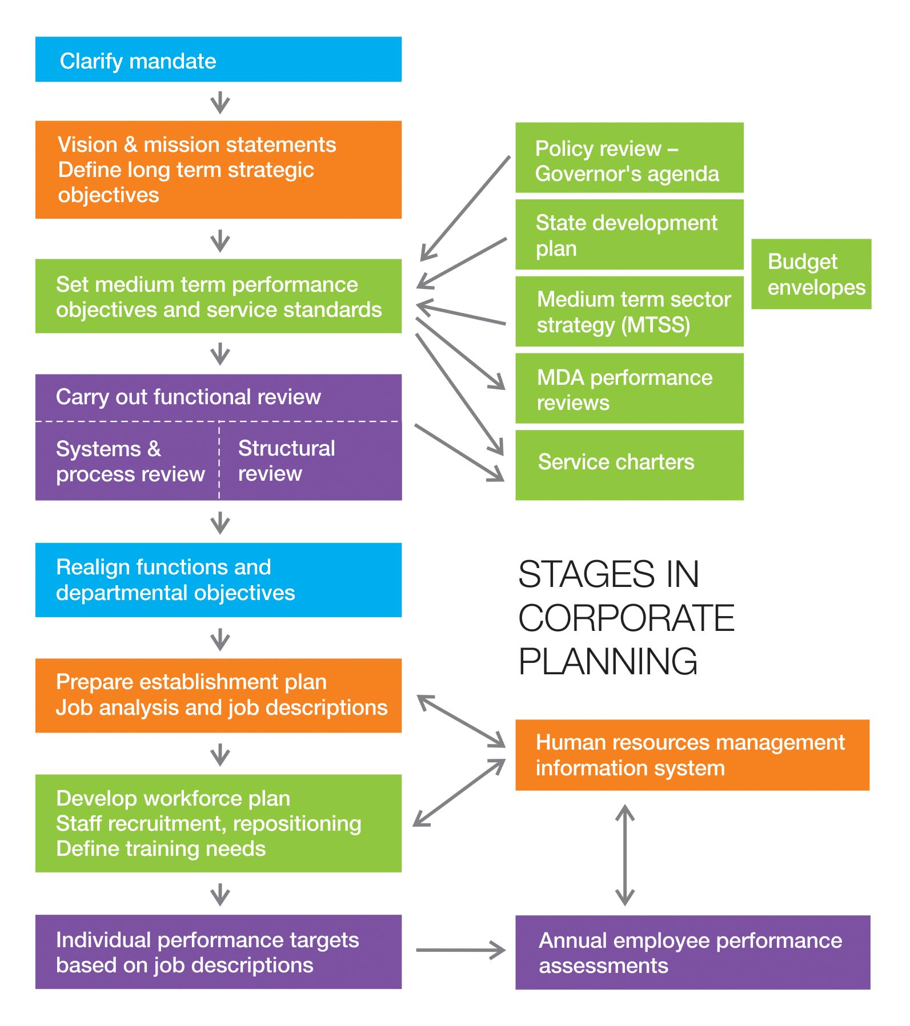

The MDA mandate is usually confirmed by the highest levels of government through the constitution, a law or other legal instrument. On the basis of its mandate, an MDA can then develop a vision statement and its mission which articulate the sense of direction and travel to staff and the public. This leads on to the next stage in which the MDA identifies its long term strategic objectives – the priority services and outputs to be delivered over five to ten years based on analyses of the developmental challenges confronting it. These strategic objectives set the scene for the formulation of more precise medium term objectives. They also offer a strategic perspective on whether the MDA will have the right volume and type of skills to deliver what is expected.

The medium term performance objectives take account of political manifestos, short term priorities, likely budget and other resource envelopes. They are usually set for three to five years and revised annually to take account of new issues and implementation performance. The medium term objectives should normally be set with performance standards against which actual performance can be measured. They can also be used as the basis for public service agreements or service charters – contracts of service delivery commitments made by MDAs to the public.

Delivering on the medium term performance objectives and long term strategic objectives requires a mix of well planned financial and human resources. At the objectives formulation stage, the budget needed and its availability should also have been identified and agreed. The next challenge is therefore how to organise the human resources, structures and systems of the MDA. The starting point for reorganisation is to conduct functional, process and structural reviews which involve clarifying core functions (derived from the mandates and medium term objectives), identifying service delivery processes, and ultimately re-aligning the structure of the MDA (the departments, units etc.) so they can most effectively and efficiently deliver these functions and processes. The end point of the reviews will be clear terms of reference for each department, section or unit.

Once the overall structure is decided, it is possible to look in more detail at the internal make-up of each department, section and unit etc. i.e. to produce an establishment plan. This involves identifying the key posts, drawing up job descriptions and linking the jobs to the salary grades.

The next challenge is to match the existing workforce with the establishment plan. This will highlight those areas that require repositioning of staff, workforce training, recruitment and rightsizing, and will culminate in the preparation of a workforce plan.

Ultimately each employee will have a clear job description from which annual targets can be derived, thereby providing the basis for individual performance assessment. The workforce plan will also enable the MDA to provide individual career development and training plans for its employees.

Corporate Planning and MDA Performance
A corporate plan guides the management and staff of the ministry in a cohesive effort to carry out the ministry’s mandates. The ultimate goal is to enhance individual, and directorate, MDA and sectoral performance. How corporate planning fits with the bigger picture of MDA and sector performance, including public service accountability to citizens is illustrated below in Figure 2.

Figure 2: Performance and Corporate Planning
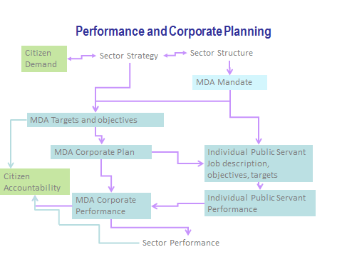

Corporate Planning: Transformation and Change Management
Corporate planning is, in essence, a process of enabling the MDA to be more agile in the present fast moving world. Institutions are being constantly challenged to keep pace – change is all pervasive in terms of expectations, technologies, attitudes, politics, resource availability etc. MDAs need to recognise that:

Change is inevitable; better to harness it than ignore it
Transformation is about challenge and opportunity
Change is about people – it requires the active participation of all personnel
Change is a perpetual process – requiring constant review of an MDA’s structure, systems and processes in order to achieve its mandates
Transformation is about ownership by all stakeholders
Transformation requires competent change agents to help steer the process
Successful change requires a clear sense of direction and visible commitment from top management who are able to make complex issues easy for others to understand
Public service transformation and change are about providing better value for citizens.

Leadership and top management support are crucial to the success of change management and corporate planning. The support should signal a readiness to embark on a transparent process which intends to achieve improvements in effectiveness, efficiency and service delivery. It should also signal commitment to follow through on whatever plans are produced without favour to any particular group in the process. Top management includes the head of service, commissioners, permanent secretaries and directors. They need to be committed to positive transformation and change and to initiate and drive the process. The following point to success:

- A sustainable approach to corporate planning needs vision and leadership authority, both of which can only come from the top
- Whilst top management should drive the process, they should do it by facilitating, guiding and enabling rather than simply imposing
- People need to understand the reasons and objectives of the corporate planning process and see a plan for its implementation so they know where they and their MDA are trying to go
- Communication and openness are essential for obtaining agreement and support from people within the system
- This all implies a need for face-to-face communication bottom-up, top-down and across the organisation, as well as traditional written guidance to staff.

Corporate planning should, if managed successfully, inject energy into the organisation.

Introducing Corporate Planning into a State
When an organisation has been nominated as the pilot MDA to test the corporate planning process, it will need technical support to instigate and deliver:

- A top level steering group to oversee the process and endorse the pilot and plan
- A senior group to lead in implementing the plan in the MDA
- Clarification and communicating the mandate
- Establishing vision, mission and value statements throughout the MDA
- Environmental and situational scanning to inform the setting of goals and objectives
- Establishing long term goals, objectives, strategies and performance criteria in the MDA – these should be derived from and aligned with an MTSS or similar medium term strategy for the MDA and/or sector
- Setting medium term objectives and performance standards
- Developing a service charter – this is not an integral requirement for the corporate planning process but may be linked to it if appropriate for the MDA concerned
- Conducting functional, structural and process reviews
- Updating the establishment plan
- Developing a workforce plan
- Producing and communicating the corporate plan
- Developing an implementation plan
- Identifying lessons that have wider application in state MDAs.

It is important to set a date for when the pilot should start and be completed by.

The Corporate Plan Format
A corporate plan will summarise the results of the process for each MDA involved in corporate planning. It cannot be written in a vacuum without going through the process or it will lack value and be meaningless. More importantly it will not signal the changes that may be needed to improve performance.

The Benefits of Corporate Planning
There are a number of benefits to be derived from corporate planning for the state, MDAs themselves and individuals.

For the state overall:

- Confidence that the purpose and organisation of MDAs has been subjected to rigorous review and made clear to commissioners and staff
- Better understanding and articulation of long term and medium term strategies and planning across the public services and specific sectors, in conjunction with MTSS and medium term expenditure framework (MTEF)
- Clarity about staffing across the public service and where changes may need to be made
- The mechanism to keep MDAs under regular review.

For MDAs:

- A holistic understanding of the MDA’s purpose, structure, function and staffing issues
- A clearer link between resources and MDA purpose and objectives
- Information about current and future jobs, staffing and skill needs
- Individual performance targets linked to MDA performance
- The means to better monitor performance and adjust plans.

For individuals:

- A clearer understanding about the role and function of their MDA
- A clearer understanding about their job and how they can contribute to MDA performance
- More personal motivation and recognition for their contribution, training and development that is related to jobs and personal capability.

