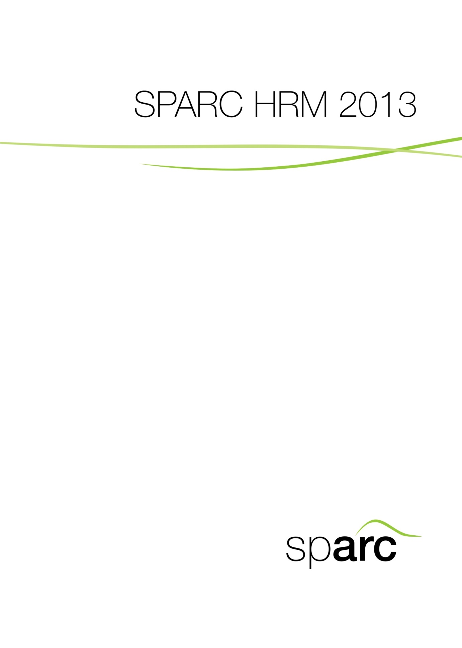
HR Practitioner Tools

3B:
Guide to
Personnel
Record Keeping
Guide to Personnel Record Keeping

This document is intended to provide a guide to the standardised record keeping of personnel records in the state.

It should be read in conjunction with the MDA’s own internal filing and registry procedures.

Contents

Chapter 1: Personnel Record Keeping Principles 3
Chapter 2: Establishing Personnel Records 4
Chapter 3: Maintaining the Personnel Folder 5
Filing Documents 5
‘Jointly Owned’ Personnel Folders 5
Chapter 4: Responding to Requests for Information 6
Request from Current Employee 6
Amendment Requests 6
Requests from Government Officials 7
Chapter 5: Transferring Records 7
Transferring Records to Another MDA 7
Transferring Records to the OHOS 8

Chapter 1: Personnel Record Keeping Principles

This chapter describes general principles governing the creation, maintenance, and disposition of records used to document personnel records, established by the Office of the Head of Service (OHOS) or other responsible ministry, department or agency (MDA).

Records include all papers, maps, photographs, machine-readable materials or other documentation, regardless of physical form/virtual form (electronic), made or received by the government in connection with the transaction of public business and preserved as evidence of decisions, operations or other activities of the government.

Personnel records may be created because they are required by:

- Statute or executive order
- Regulation
- Operational guidance from service-wide MDAs
- MDA records management programmes.

Each office or programme that requires agencies to create personnel records, which may be used in making any determination about an individual, is responsible for establishing minimum standards of accuracy, relevancy, necessity, timeliness and completeness of the record. An MDA holding an Official Personnel Folder (OPF) concerning one of its employees is the custodian of the OPF during the period the employee is part of the MDA workforce. The MDA is responsible for the maintenance of that record regardless of format or media employed.

An MDA may establish its own personnel record keeping requirements to meet special needs. If an MDA establishes its own system of records, the MDA is responsible for ensuring the keeping of these documents is compliant with any government data management policy that might exist.

MDAs should have management controls to ensure personnel records:

- Adequately document human resource management operations
- Are accurate and timely
- Are protected against loss or unauthorised alteration
- Document the employment history of individuals employed by the state government
- Can be located when necessary
- Are retained and disposed of as required
- Are secured against unauthorised access.

Access to personnel records should be limited to those whose official duties require such access. The records should remain subject to the MDA’s control at all times. Any employee who discloses personal information from personnel records knowing that such a disclosure is unauthorised may be subject to disciplinary action.

Electronic records are information recorded in a form only a computer can process. Electronic formats include any media read by a computer. Where electronic systems are used, they should:

- Be thoroughly documented
- Be capable of producing legible paper copies of all records
- Have access controls to ensure a high level of security and confidentiality
- Allow correction and removal of erroneous records under strict authorisation control
- Include backup and disaster recovery procedures
- Provide for regular recopying, reformatting, and other maintenance necessary to ensure that the records will be retained and useable throughout their life cycle
- Identify information in a way that authorised users can retrieve and maintain the required records.

Chapter 2: Establishing Personnel Records

This chapter describes procedures for establishing inter-MDA personnel records when an MDA hires an individual. Inter-MDA personnel records include:

- Personnel folders
- Medical folders
- Performance records.

Each employee should have a single personnel folder that will document the entire period of service. The procedures described in this chapter are designed to ensure all appropriate inter-MDA personnel records are available in a single folder.

OHOS or MDA instructions should be followed when establishing employee personnel, medical and performance files. If long term occupational medical records are created for the employee, these records should be combined in a single medical folder that will be used for the entire period of service. Performance records transferred from a previous employer may be filed with performance records created in the current MDA.

Personnel records that document an individual’s state career are placed in a single paper OPF or electronic OPF. It is especially important to label the personnel file correctly. The critical identification information is:

NAME: The employee’s legal name should appear exactly as it appears on his/her birth certificate.

DATE OF BIRTH: The date of birth should appear exactly as it appears on his/her birth certificate.

STAFF ID NUMBER: The employee’s unique staff ID number should be recorded directly under his/her name.

PERFORMANCE RECORDS: The OPF should contain the performance records transferred from MDA to MDA. If the performance records are not in the folder and it appears the employee was subject to a performance appraisal system, request the records from the former MDA.

MEDICAL RECORDS: Review records in the employee medical folder to ensure they are in chronological order. Combine these records with any medical records created during the appointment process.

PERSONNEL RECORDS: Check the documents for completeness and accuracy. Follow the appropriate programme instructions to correct any errors. Combine all appropriate records in chronological order in a single folder.

Chapter 3: Maintaining the Personnel Folder

Filing Documents
Records are filed in the OPF to document events in an individual’s state employment history that have long term consequences for the employee and the government. Care should be exercised in filing documents correctly to ensure all documents pertaining to an employee's rights and benefits are available in the personnel folder when needed.

Before filing documents in the personnel folder:

- Make sure the document should be filed in the personnel folder. Some documents must never be filed in the personnel folder (e.g. talent maps, documents relating to other officers or a group of officers, confidential HR documents, tools or templates to aid decision making). Other documents belong in case files rather than the personnel folder
- Place the document correctly in chronological order.

‘Jointly Owned’ Personnel Folders
Chapter 1 of this guide indicated that the ‘parent’ MDA is responsible for all personnel folder records that are established under its record keeping authority.

MDAs maintaining records under the parent MDA’s record keeping authority must establish a single personnel folder for an employee’s entire state employment history. This single folder may contain personnel records established by agencies that have their own personnel folder record keeping authority. We refer to such folders as jointly owned personnel folders.

Once an MDA receives or establishes a jointly owned OPF, that MDA must:

- Maintain a single personnel folder, containing all required records
- Use all records to make personnel decisions affecting the employee
- Provide a copy of records to anyone with the employee’s written permission to receive or review the records
- Disclose information from all records to MDA employees and officials who need the records to perform their duties.

However, they may not:

- Amend any records in the folder that the responsible MDA does not own
- Destroy any records in the folder that the responsible MDA does not own
- Remove any records that the responsible MDA does not own
- Adjudicate an appeal of an amendment to a record that the responsible MDA does not own
- Enter into a settlement agreement on disposition of records that the responsible MDA does not own
- Disclose information to the public from any record that the responsible MDA does not own.

The MDA maintaining a jointly owned OPF may wish to initiate one or more of the above-listed actions or may receive a request for such actions. In such situations, the maintaining MDA should refer the proposed action or the request to the MDA that owns the records.

Chapter 4: Responding to Requests for Information

Request from Current Employee
An employee’s OPF must be made available to the employee for review upon request. This is called access. Employees are required to present proper identification before the personnel folder is provided to them. Employees reviewing their own folders must be accompanied by a record custodian at all times.

Amendment Requests
Amendment of personnel folders means the correction, addition, deletion or destruction of a specific portion of a folder. Any request for amendment should include:

- A precise identification of the record to be amended
- Identification of the specific material to be deleted, added or changed
- A written statement of the reasons for the request, including all available material substantiating the request.

In processing amendment requests, the MDA should ensure any amendments comply with the state’s record keeping procedures and regulations.

When an MDA denies an employee’s request to amend a personnel record, the employee should be notified of the decision in writing.

Requests from Government Officials
Disclosure is providing personal review of a record, or a copy thereof, to someone other than the data subject or the data subject’s authorised representative.

Personnel and medical folders are available to officials within the MDA who need to review records to perform their assigned official functions. MDA officials include HR officers, managers and supervisors.

Government officials outside the MDA may also be authorised to review an employee’s records under limited conditions such as:

- Where the release is specifically authorised by the OHOS
- For a routine use where government-wide systems allow disclosure of the records.

When in doubt, check with the OHOS whether records may be disclosed.

Chapter 5: Transferring Records

When an employee leaves the MDA, the losing personnel office sends inter-MDA personnel records to the receiving MDA.

If the employee is leaving service, the losing personnel office sends inter-MDA personnel records to the OHOS.

This chapter describes the procedures used to transfer inter-MDA personnel records (personnel folders, medical folders, performance records) to another personnel office or the OHOS.

The general rule is that each employee will have a single personnel folder that documents the entire period of service. If long term occupational medical records are created during the employee’s service, those records will be in a single medical folder. The personnel and medical folder ‘travel’ with the employee throughout his/her entire career. When an employee separates from service, the folders are stored by the OHOS for archiving.

Transferring Records to Another MDA
Requests for an employee’s personnel records should be made in writing and should include documentation of the employee’s appointment in the requesting MDA. The records should be sent to the new MDA promptly unless some records that should be transferred are not available. If there is a delay, the requester should be notified.

There are a number of steps to consider when preparing personnel folders for transfer:

- Check the personnel folder to make sure that it contains all the long term documents that should be in the folder
- Make sure that all documents are filed in chronological order
- Send the folders to the next MDA.

When long term paper documents that should have been transferred to the next MDA are discovered after the folders have been transferred, they should immediately be forwarded attached to a cover letter that identifies the employee by name, staff ID number, and date of birth.

Transferring Records to the OHOS
When an employee separates from the service, the last employing MDA sends the OPF to the OHOS for storage.

Under normal circumstances, the personnel folder, including performance records and the medical folder should be transferred to the OHOS for storage within 90 days after an employee separates from the service, unless particular circumstances require them to be retained for longer, such as:

- A retirement or death claim is being processed
- The MDA expects to reemploy the person shortly after the separation
- The employee has an ongoing appeal, grievance, complaint or similar process
- The employee is entitled to severance pay.

Former employees’ request for copies of their personnel records must be in writing and should include:

- The full name (or names) used while employed
- Staff ID number
- Written signature
- Proof of identity
- Date of birth
- If known, the year of separation and last employing MDA
- An address to send the response/copy of records as well as a daytime telephone number.

Personnel records should be securely packaged to ensure that they arrive in good condition. Employees are not authorised to carry their own records to the next employer. Records must be sent via official courier and receipt formally acknowledged.

