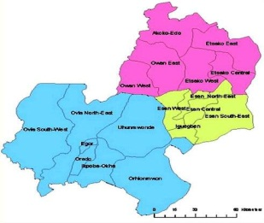

1-DAY REVIEW AND 2021 WORKPLAN MEETING OF LOCAL GOVERNMENT COMMITTEE ON FOOD & NUTRITION IN THE THREE SENATORIAL DISTRICTS OF EDO STATE ORGANIZED BY THE STATE COMMITTEE ON FOOD AND NUTRITION IN COLLABORATION WITH UNICEF.
DATE: - Tuesday 12TH January, 2021. TIME: - 09:00AM.
VENUE: - Oredo Local Government Council Hall, Benin City.
S/N | ACTIVITY | RESPONSIBLE PERSONS | TIME
1. | Registration | All Participants | 09:00am-09:30am
2. | Opening Prayer | All Participants | 09:30am -09:35am
3. | Self-introduction | All Participants | 09:35am – 09.45am
4. | Objective of the meeting | SCFN Desk Officer | 09:45am – 09:50am
5. | Opening Remarks | Chairman SCFN. | 09.50 am - 09.55am
6. | Welcome Remarks | Chairman of Host LGA | 09.55am - 10.00am -
7. | Tea Break | All Participants | 10.00am- 10.30am
8. | Group work -Review  of LGCFN 2020 Activities &Presentation of Reports. | Nutrition focal person. | 10.30 am - 11:30 am
9. | The imperatives of vegetable Farming for vitamins and minerals. | Director – Agric Extension services(ADP) | 11.30am- 12.00pm.
10. | Overview Of Nutrition Programmes in SPAN(2019-2023). | State Nutrition officer - EDSPHCDA | 12.00pm- 12.30pm.
11. | Development of 2021 Work Plan(Group Work) - Sector by Sector . | Breakout Sessions. | 12.30pm -02.00pm
12. | Presentation of Group Work. | Reps. of Sectorial Groups | 02.00pm -02.30pm
13. | LUNCH | All Participants. | 02.30pm– 03.00 pm
14. | Administrative Instructions/ Announcement. | Mr. Sunday Oshiomah | 03.00pm -03.05pm
15. | Closing Remarks. | Director -MBEP | 03.05pm –03.10 pm

