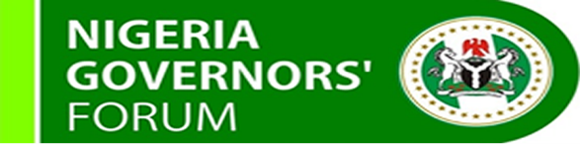

HEALTH UPDATE
  - JUNE 27TH, 2018

Highlights
- Saving One Million Lives (SOML)P4R - Disbursement of funds have commenced.
- Polio – 22 months polio free, 14 months to go. National Immunization Plus Days commences in July, 2018.
- Primary Health Care Under One Roof (PHCUOR) – Scorecard assessment completed in the 36 states and the FCT.
- World Sickle Cell Day – World Sickle Cell Day was commemorated on the 19th of June, 2018.

Polio
- Nigeria 22 months Polio-free; 14 more months to go!
- National Immunization Plus Days will commence in all 36 states and the FCT in the first week of July, 2018.

Primary Health Care Under One Roof (PHCUOR)
- The NGF supported the NPHCDA in carrying out a scorecard assessment to ascertain the level of implementation of PHCUOR across the 36 states and the FCT from the 15th of May to the 1st of June, 2018.
- NGF team participated in the field assessment in eight states – Adamawa, Akwa Ibom, Cross River, Enugu, Kwara, Niger, Osun, Oyo and Zamfara.

National Council on Health (NCH)
- The NCH, which is the highest decision-making platform in the health sector, held on the 21st and 22nd of June, 2018 in Kano.

Health Financing
- The Basic Health Care Provision Fund has been included in the 2018 budget.
- Disbursement of funds from SOML has commenced.

World Sickle Cell Day
- This is commemorated yearly on the 19th of June, to raise awareness about Sickle Cell Anaemia
- Governors are encouraged to liaise with religious leaders to advocate for compatibility testing between couples before marriage.

CALL TO ACTION FOR GOVERNORS
- NGF to appoint champions to follow up on the release of the BHCPF.
- Governors to expedite action to ensure successful take-off of State Social Health Insurance Scheme to enable them access BHCPF.
- Governors to expedite action to ensure that the PHCUOR policy is fully implemented in their respective states.
- Sustain commitment to polio eradication.

