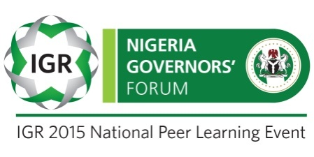
STATE-SPECIFIC RECOMMENDATIONS

Scorecard for Sokoto State

Sokoto State’s internally generated revenue (IGR) grew by 9.6% in the last five years, from N3.9 billion in 2010 to N5.6 billion in 2014. It was also 9% of the State’s total recurrent revenue in 2014. The State’s performance has remained relatively poor, generating a monthly average less than N500 million while its fiscal dependence on federation revenues was approximately 91%.
IGR SNAPSHOT IN THE NORTH WEST ZONE (2014)
S/N | STATE | MONTHLY IGR (N) | ANNUAL IGR (N) | 5 YR GROWTH RATE | IGR/RECURRENT REVENUE (%) | IGR PER CAPITA (N)
1 | KANO | 1,138,487,827.99 | 13,661,853,935.85 | 19.9% | 14.1% | 1,120.78
2 | KADUNA | 1,065,210,209.54 | 12,782,522,514.51 | 2.5% | 15.9% | 1,650.55
3 | JIGAWA | 522,775,884.70 | 6,273,310,616.35 | 49.9% | 9.8% | 1,144.42
4 | KATSINA | 518,586,466.58 | 6,223,037,599.00 | 18.5% | 8.9% | 846.76
5 | SOKOTO | 468,146,938.36 | 5,617,763,260.35 | 9.6% | 9.0% | 1,197.71
6 | KEBBI | 319,511,970.16 | 3,834,143,641.95 | 0.2% | 6.6% | 922.24
7 | ZAMFARA | 262,469,212.83 | 3,149,630,553.96 | 11.1% | 5.8% | 746.62

Commendable Practices:
- IRS budget release is reliable and performance-based
- Streamlined procedures and simplified tax forms are implemented
- Sokoto State has sufficient number of trained tax auditors
- It has also passed a Bill into law that ensures effective reduction in leakages and corrupt practices through increasing transparency and sanctions – though yet to take effect
- Property and consumption tax law is approved and implemented
- Informal sector businesses are being identified for tax payment purposes
- Double taxation at the State and local levels has been largely eliminated, with little usurpation of the taxing authority of LGAs by State governments.

Major challenges that have hindered growth in IGR:
- No incentive for staff other than civil service salary. Most staff also lack technical skills and training
- It also adopts manual methods of processing tax forms and payments
- The State uses an ad hoc application of user fees for sanitation, transport, and education utilities.
- Some degree of leakages and corruption still exist
- Insufficient coverage of the district offices
- TIN is introduced but not effective and unified.
- Fragmented taxpayer database, thus making it difficult to use for planned tax collection.
- No clear debt management policy or process.

STATE’S ACTION PLAN
S/N | Identified goals | Reforms required | Timeline | Responsibility
1 | To adopt an integrated tax processing system of administration both for assessment and collection of taxes | Full automation of the Board of Internal Revenue (BIR) | Six months – May 2016 | Sokoto State government
2 | Blocking all revenue leakages | Use of POS terminals  automation and  frequent monitoring and audit | Immediate | Board of Internal Revenue
3 | Autonomy of the board | Granting of cost of collection | One year | Sokoto State government/ ministry of finance

