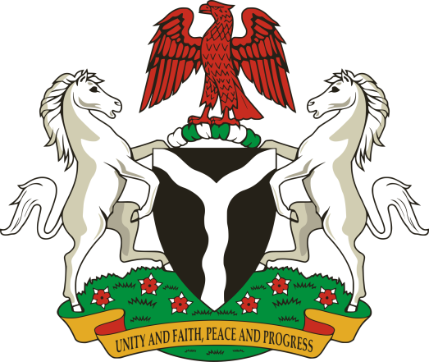

REMARK BY THE HONORABLE MINISTER OF WOMEN AFFAIRS AND SOCIAL DEVELOPMENT, HAJIYA AISHA ABUBAKAR AT THE NIGERIA GOVERNOR’S FORUM: GOVERNORS’ SPOUSES’S SUMMIT HELD AT THE PRESIDENTIAL BANQUET HALL, STATE HOUSE, ABUJA ON 1ST MAY, 2019

Protocol,
Your Excellencies, it is my honour and privilege to make this remark on this occasion of the Governors Spouses Summit. I wish to seize this occasion to congratulate Your Excellencies on your spouse’s victory at the just concluded general elections. Your support and efforts are worthy of commendation. As you may be aware, Wives of Public Servants, especially Governors’ wives hold strategic positions in our efforts to impact our people.
2. Permit me to appreciate the good work some of you have been doing towards improving the quality of lives of women, children and other less privileged members of our society through your pet projects. Some of those projects share common goals and objectives with the Ministry’s mandate. I am therefore, confident that we will have a good working relationship to minimize waste and duplication for high impact on the lives of our people.
3. As your Excellencies may be aware, Nigeria remains the largest country in sub-Saharan Africa with a population of about 183 million, out of which 52% are women, with the total number of the vulnerable groups which includes (children, the elderly and persons with disabilities) constituting about 70% of the entire population.
4. The Ministry of Women Affairs and Social Development is charged with the mandate of coordinating, promoting and protecting the rights of these category of citizens including the integration of their issues and concerns into national development. This is referred to social inclusion.
5. This therefore, underscores the vital role States and indeed, the Wives of Governors’ can play, not only in contributing to the actualization of the Ministry’s mandate but in the stabilization, growth and prosperity of our populace.
6. I would therefore, like to solicit for your kind support, contribution and cooperation on issues relating to the advancement of women, the welfare of children and the upliftment of the lives of other vulnerable members of our society particularly in the implementation of some of the Ministry’s priority areas some of which include:
- Women Economic Empowerment and Financial Inclusion; though I must admit the terminology empowerment often limits our desire to see women become economically independent,
- Women’s increased Participation in Politics and Decision-making positions; particularly at the local government level,
- Improving Maternal and Child Health indices by enhanced support to primary healthcare centers. On a daily basis 145 women die due to inadequate maternal care. That’s a plane full of passengers.
- Promoting Women and Girl formal and non-formal education; as this is the only way women can understand their basic human rights and contribute effectively to attaining their civic rights
- Passage of the Gender and Equal Opportunity Bill (which seeks to domesticate the UN Convention on the Elimination of all forms of Discrimination Against Women (CEDAW) provisions and implement the National Gender Policy);
- Domestication, Passage and Implementation of the Child Rights Act at the sub national level
- Improving the living conditions of State owned orphanages
- Eliminating Violence and Harmful Traditional Practices against Women and Children; by providing safe shelters and effective response mechanisms
- Social Inclusion for Persons with Disabilities; by changing the mindset of all, from that of welfare to active economic contributors,
- by ensuring sustainable infrastructure, including access to clean energy, safe drinking water and sanitation, safe designing of transport systems to facilitate mobilIty and
- Empowerment and Support for the Elderly;by providing enabling an environment for them to continue to contribute to community development
- Rehabilitation of Ex-Juvenile offenders among others.
7. As stakeholders, these issues concern us as mothers, wives, sisters, daughters, as we have been charged with our inherent God given skills and by constituting almost 52% of the population of this nation. We will greatly limit our chances of achieving sustainable development by the year 2030 if we do not make conscious and sustained efforts to tackle gender inequality and problems besetting these groups. This we have to do together.
8. I enjoin Your Excellencies to facilitate and support the enactment of appropriate legislation(s) that will strengthen education, the health system including access to ante-natal and post- natal care for safe birth, in addition to passing laws for a complete free medical care for pregnant women and children under 5 to reduce the high maternal and child deaths in the various states.
9. Your Excellencies, illiteracy is catastrophic for any child but devastating for girls, because it makes them more vulnerable to poverty, ignorance, maternal mortality, hunger, violence, abuse, exploitation, trafficking, HIV/AIDS and other problems. I therefore, request Your Excellencies to facilitate the building of strong institutions and enabling environment for the State Ministries of Women Affairs and Social Development to thrive, so that whatever pet project you start will be within the Ministry’s priority area of action and such can be sustained even long after you have left office. I am therefore advocating that, Excellencies Wives of Governors key into existing programmes and projects for institutional support, maximum impact and sustainability.
10. Your Excellencies, as you assume office, I solicit your support in sensitizing authorities, popularizing the essence of inclusive governance at state level, and the need to have appropriate legislation(s) that would guarantee the rights of women and girls, the promotion of the welfare of children including the aged and persons with disabilities. It is also important for each State to concentrate on areas where they have comparative advantage, give special attention to peculiar issue(s) affecting the people and introduce appropriate policies and programmes to address such concerns.
Annually the National Council on Women and Social Development where policies and programmes are deliberated upon including emerging issues and challenges of implementation, I urge YE to utilise this platform for effective synergy. The 64th Commission on the Status of Women comes up in March every year and this is the United Nations highest policy making body. Please let’s seize this opportunity to present our Nations developmental efforts towards Women. This year’s focus is Beijing plus 25.
11. In conclusion, permit me Your Excellencies, to seize this opportunity to request you to kindly work with the National Centre for Women Development and indeed with the Women Centres in your respective States to ensure their repositioning for the well being of women. I know that once upon a time the National Centre for Women Development at inception, used to have shops or show rooms dedicated and managed by each State of the Federation to demonstrate their skills of their women’s skills and States potentials and natural endowments. This act, when resuscitated will not only contribute to the creation of innovative markets, investments and industry-wide actions that can advance gender equality and self-reliance of women and girls but will boost government revenue from non-oil products.
12. Once again, YE I congratulate you on your new or renewed roles as mothers and wish you God’s guidance and protection. I thank you, for the attention and wish you fruitful deliberations.

