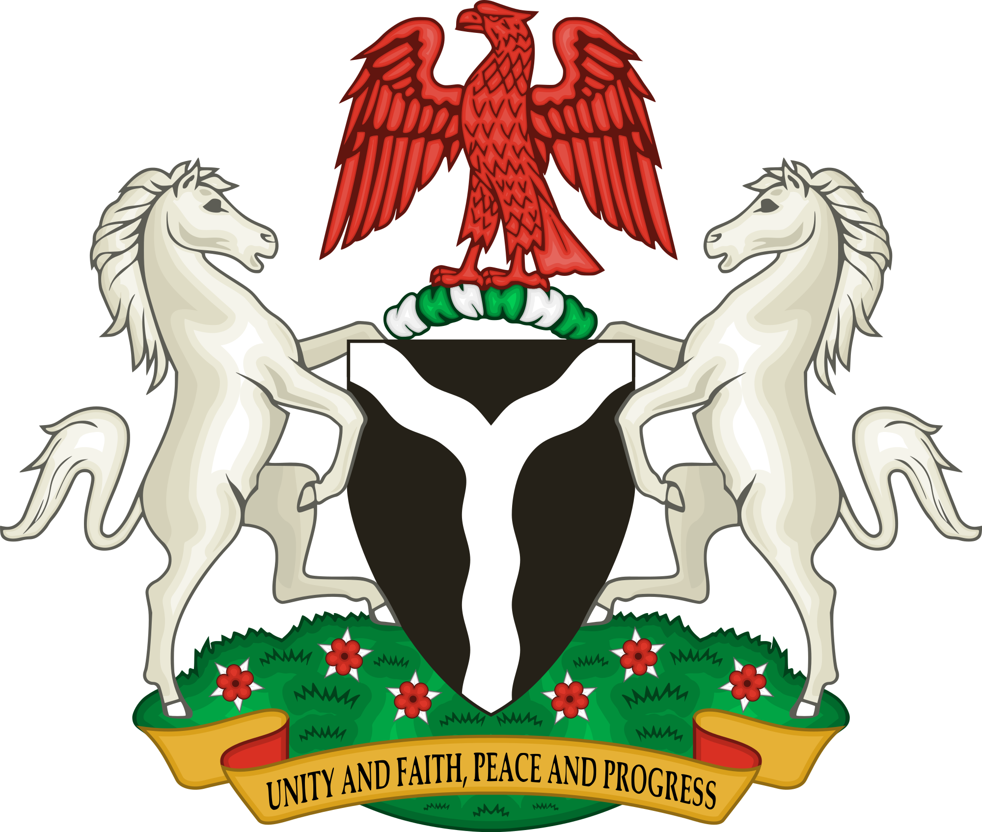
STATEMENT FROM WIVES OF GOVERNORS OF THE FEDERAL REPUBLIC OF NIGERIA, CONCERNING VIOLENCE AGAINST WOMEN AND CHILDREN IN NIGERIA.

We have observed with dismay, the intense levels of violence against women and children in the country. As mothers, we empathize with survivors of these heinous acts and urge them to be courageous in speaking up, no matter how long it takes. We salute them.

We lend our voices to that of our First Lady, HE Dr Aisha Buhari, who recently called for action to be taken on the increasing rate at which women and children are being sexually abused in Nigeria. On a daily basis, we are inundated with cases of defilement (of even babies of six months old), rape, domestic violence, sexual harassment and murders of women and children.
It is also worrisome that women and children with special needs have also become targets of sexual violence. We note with concern that in spite of the existence of laws at the federal level such as the Violence Against Persons (Prohibition) Act of 2015 as well as legislations at State level to protect the well-being of women and children, perpetrators continue their despicable acts with impunity. On the rare occasions when incidences of rape are reported, victims are intimidated and shamed into silence.

As concerned mothers and citizens, we hereby:
- Call on the Inspector General of Police to direct the Nigerian Police to treat rape and defilement cases with the speed and seriousness such cases deserve, in order to ensure justice for victims. We are also requesting that the Nigerian Police should be tactful and supportive in the handling of alleged sexual offences and take measures to prevent the intimidation of victims by families and associates of suspects. We are also appealing for Rape and Sexual Offences desks to be created in Police Stations across the country where they do not exist, and that appropriately trained personnel are designated to provide timely support for victims.
- Implore the Attorney General of the Federation as well as State Attorney Generals to fast track cases of rape and defilement. We also urge the setting up of Special Offences Courts for rape and defilement cases, and for such cases to be charged to the courts and heard without undue delays.

- Beseech the Minister of Health to ensure the provision of timely, sensitive and comprehensive medical services to victims of sexual violence. We plead that all medical facilities be equipped with Rape Kits and Post- Exposure Prophylaxis (PEP) to prevent rape victims from contracting HIV. It is also our hope that professional counselling services can be made available to sexual violence survivors.

- Appeal to the National Assembly, Executive Governors and State Houses of Assembly to facilitate the passage of laws to protect women and children from violence and abuse. Where legislation already exists, we call for political will in the enforcement and implementation of such laws. In this regard, urgent medical attention, shelter, counselling and other support mechanisms for survivors are important.

- Plead with all political, religious and community leaders to speak up against the abuse of women and children.

- Encourage civil society organisations and women’s support groups to continue to advocate on behalf of victims as well as provide all relevant services. We acknowledge the efforts of organisations such as WRAPA, which was created by former First Lady, HE Justice Fati Abubakar, and many others across the country who have been working tirelessly on these issues.

- Urge the general public to address this issue by supporting victims to get justice and breaking the culture of silence and stigma which prevents victims from coming forward.

As Wives of Governors, we are committed to using our positions to support all efforts aimed at mitigating this scourge. Nigerian women and children deserve to live their lives free from abuse of any kind.

Signed
HE Erelu Bisi Fayemi, Wife of Chairman, Nigerian Governors Forum
HE Dr Amina Abubakar, Chair, Northern Governors Wives Forum
HE Mrs Betsy Obaseki, Chair, Southern Governors Wives Forum

On behalf of Nigerian Governors Wives
Date: July 23 2019

Cc: HE Dr Aisha Buhari, 1st Lady, Federal Republic of Nigeria
HE Hon. Ahmed Lawal, Senate President
Rt. Hon. Femi Gbajabiamilla, Speaker of the House of Representatives
Chief Justice of Nigeria
IG Abubakar Mohammed Adamu, Inspector General of Police
HE Dr Kayode Fayemi, Chairman, Nigerian Governors Forum
Hon. Boss Mustapha, Secretary to the Federal Government
Permanent Secretary, Ministry of Justice
Permanent Secretary, Ministry of Health
Mr Dayo Apata, Solicitor General of Nigeria

