REPORT OF 2021 FIRST QUARTER REVIEW AND COORDINATION MEETING OF THE STATE COMMITTEE ON FOOD AND NUTRITION (SCFN)

ORGANIZED BY:

MINISTRY OF PLANNING AND BUDGET

IN COLLABORATION WITH

UNICEF FIELD, KANO HELD ON 2nd JUNE,2021
INTRODUCTION
The first quarter review and coordination meeting was conducted based on partnership between the Ministry of Planning and budget and UNICEF. The specific objective of the meeting is to ensure effective implementation of nutrition activities in line Ministries Department and Agencies. It will also provide a forum through which members from line Government agencies, relevant organizations, and CSOs involved in implementing nutrition activities met, interacted and shared information and experiences and reviewed nutrition implementation status in the state.
OPENING REMARKS
In his opening remarks, the Chairman SCFN/Permanent Secretary Ministry of Planning and Budget began by welcoming all participants to the first quarter meeting.
He extended his appreciation to UNICEF Field Office for being supporting Kano State in the area of Nutrition, Health, Education, Water and Sanitation amongst others to mention but a few.
Similarly, the Chairman further highlighted the negative consequences of malnutrition which increases the frequency and severity of such infections, and delays recovery.
In another development, the Chairman called on the Nutrition Desk Officers to continue putting their best in their respective roles to programme and sustain ongoing advocacy to ensure efficient use of approved Kano State Nutrition Policy and Multi-Sectoral Plan of Action on Nutrition in the to ensure that all forms of Malnutrition is combatted across the State.
He appreciated the participants for honouring the invitation to attend the meeting and hoped that their participation will bring about the desired changes through dedication and hard work.
He finally declared the meeting open after wishing all participants successful deliberations.
READING, CORRECTION AND ADOPTION OF MINUTES OF THE LAST MEETING
The minutes of the last meeting which was held on 6th January, 2021 was read by Dalhatu Danladi. After observations and due corrections, a motion for adoption of minutes of the last meeting was moved by Hajiya Asma’u Ahmad from SWODEN and seconded by Binta Abubakar from KNARDA.
DELIBERATIONS AND RESOLUTIONS:
- It was resolved that Ten (10) Sub-committee should be constituted to identify major challenges faced by the SCFN and come-up with the possible recommendations in the subsequent SCFN meeting.
- It was observed that there was no evidence of pregnant women receiving Iron folic form SPHCMB presentation.
- It was deliberated that the State Emergency Management Agency should look at disability Law
- Called on the needs for Nutrition Emergency Preparedness for IDPs
- It was observed that prevention and treatment are critical but treatment is of high important to curtail the prevalence of malnutrition amongst malnourished children
- It was resolved that there is the need to look inward to ensure any SCFN meeting yield a fruitful result considering the resource being putting by UNICEF for the conduct of such meetings.
- It was advised for all SFCN members to come with their work plans during the meeting
- It was resolved that SFCN members should strictly adhere to meeting presentation agreed format.
- It was advised that all members should consider SCFN as a collective responsibility for all.
- It was urged that Nutrition Desk Officers should continue mobilizing resource at their respective MDAs for Nutrition, particularly the state government counterpart’s money.
- It was resolved that nutrition advocacy briefs should be developed for continues advocacy;
- It was recommended that all Line MDAs should prioritize implementation of Nutrition Policy and Multi-sectoral Plan of Action on Nutrition;
- It is resolved that, the Ministry of Planning and Budget should work towards ensuring strong synergy exist between Ministry of Health and the Primary Health Care Management Board
VOTE OF THANKS, WRAP-UP & CLOSING:
Deputy Director Planning/PME UNICEF cherished the dedication and hard-work and commitments of all the SCFN members for sparing their time to be part of the 2021 quarter one SCFN meeting, entirely quarterly reports.
He also thanked Nutrition Partners, particularly UNICEF for their untiring support at all times to the SCFN supporting the conduct of quarterly review and coordination meetings.

NEXT STEPS
S/N | ACTIVITY | TIMELINE | RESPONSIBLE
- 1 | - Second quarter Review and coordination meeting of SCFN | July, 2021 | MoPB in Collaboration with UNICEF
- 2 | - Conduct of Policy Dialogue meeting with Principal Officers and Committee on Health of Kano State House of Assembly and Key Government Officials | July, 2021 | MoPB in Collaboration with UNICEF

APPENDIX: LINE MDAs PRESENTATIONS AS FOLLOWS:
MINISTRY OF PLANNING AND BUDGET
BACKGROUND:
The Kano State Food and Nutrition Policy provide the framework for addressing the problems of food and nutrition insecurity at all levels of the State. It serves as a guide for the identification, design and implementation of the intervention activities across the various sectors to ensure adequate nutrition and health of residents of the State. Malnutrition is the impairment of health due to inadequate or imbalance of one or more nutrients. Malnutrition has multi-faceted causes and requires solutions that are multi-disciplinary and multi-sectoral cutting across various sectors including health, agriculture, science and technology, education, information and culture, economy, water resources, commerce and industry.
ACTIVITIES CONDUCTED:
- Conduct of advocacy visits to various Nutrition line Ministries on improved release of nutrition funds
- One day nutrition stakeholders meeting on leveraging partnership for sustainable nutrition programming in Kano State
ACHIEVEMENTS:
- Identified some of the challenges hindering the smooth implementation of nutrition intervention in the state
- Constituted Sub-committee to identify major challenges faced by the SCFN
CHALLENGES:
- Inadequate release of funds for the procurement of RUTF
- Inadequate resource mobilization of nutrition funds by most of Nutrition line MDAs in the State
- Weak synergy among nutrition line MDAs and Nutrition Partners in the State
POSSIBLE REMEDIES:
- Continuous advocacy and evidence-based engagement with all nutrition actors
- Regular mobilization of resources and sustained advocacy to Government for timely releases of resources required from budgetary allocations to fully implement the Policy of Food and Nutrition at all levels
- Timely generation and submission of Memos by Officers and implementers of Nutrition specific and Sensitive programmes
PLANS FOR NEXT QUARTER:
- Second quarter Review and coordination meeting of SCFN
- Conduct of Policy Dialogue meeting with Principal Officers and Committee on Health of Kano State House of Assembly and Key Government Officials
STATE PRIMARY HEALTH CARE MANAGEMENT BOARD:
INTRODUCTION:
Is the key government stake holder in the implementation of all health and nutrition programs, as the agency that have direct contact with over 5,000 communities and having over 1200 health facilities within its jurisdiction across the 44 LGAs.
ACTIVITIES CONDUCTED WITHIN THE PERIOD UNDER REVIEW
- Conduct of Training of Trainers on MMP
- Conduct of Capacity Building of Service providers on MMP
- Conduct of Training of Trainers on IFAS
- Conduct of Community mobilization on IFAS
- Conduct of Training of health workers on data collection as well as data validation
- Conduct First Annual Result Conference
- Conduct of Capacity Building on Orange flesh Potatoes
- National First Annual result conference from the ANRiN implementation states
- 1 day community Level dialogue session to raise awareness and create demand for maternal IFAS among 300 community platform members.
- 2 day LGA level training of 144 CSG leaders and their assistant in Bichi and Sumaila on Integration of MNP into DD project.
- Data review and validation on IFAS.
ACHIEVEMENTS:
- State and LGA stake holders from the thirteen selected LGAs on ANRiN project orientated
- Facility service providers from the 105 selected facilities on ANRiN project orientated
- Community mobilizers from the 28 selected Low performing facility communities on ANRiN project oriented.
- Orientation of Stake Holders on MNP
- distribution of MNP and data tools
- Orientation of Stake holders on IFAS
- IFAS and Data tools distributed
- Health workers on data collection as well as data validated & Trained
- Monthly Review meeting and data validation conducted
Kano State SPHCMB had achieved and exceeded their 2019 target by October 2020

INDICATORS | NUMBER OF CONTACTS TARGETED (2019) | TOTAL NUMBER OF CONTACTS ACHIEVED  (DHIS2) | MONTH WHEN TARGET WAS ACHIEVED
Antenatal Total Attendance | 6,738 | 13,132 | 20th of July and August 2020
Pregnant Women counselled on MIYCN | 6,738 | 13,132 | 20th of July and August 2020
Pregnant Women who received Haematinics | 6,738 | 12,879 | 20th of July and August 2020
IPT-1 + IPT-2 + IPT-3 | 6,738 | 10,696 | 20th of July and August 2020

CHALLENGES
- None proper coordination on all nutrition Activities
- Needs to extend the programme to other LGAs
- Misplacement of priority in the disbursement of funds
- Inadequate staffing at facilities and inadequate nutritionists in the state
- Inadequate equipment
RECOMMENDATIONS
- More trained nutritionists/dietitians should be recruited by state government for GMP CMAM and Inpatient care
- Needs to conduct GMP at all facilities
- State government should set up mechanism for the training of health workers for treatment of complicated SAM cases in secondary health facilities designated as stabilization centers in all CMAM LGAs.
RUWASA REPORT FOR THE CONDUCT OF SCFN R& C MEETING FOR 2021 Q-1
ACTIVITIES & INTERVENTIONS AREA IN THE STATE
WATER FACILITY
- 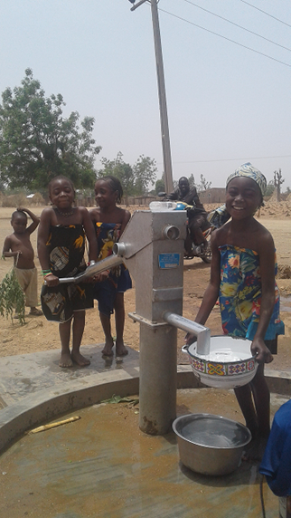
- Hand pumps
- Solar Powered Borehole
HYGIENE PROMOTION
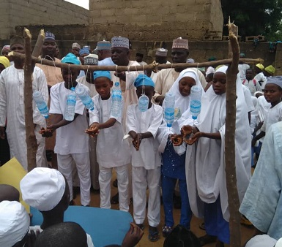
- Volunteers Hygiene Promotion
- Hygiene awareness
- COVID-19 and Hand Hygiene
ACHIEVEMENTS RECORDED
- 2 No of SMBH Constructed
- 136 No HPBH Constructed
- 10 No HP in 10 selected LGAs by Health & Development Support Programme (HANDs) Constructed
- WASH Programme has delivered safe water access to more than 42,800 persons in the state
- Each facility has a plan to manage and sustain itself through tariffs or community contributions
- WASH Structures like WASHCOMS and WCAs have been established in all facility sites for O&M
CHALLENGES
- Non-release of LGA operational funds to LGA WASH Departments hampered monitoring in communities. Continuous advocacy made by CFO with the SSG office and Ministry of Water Resources and Ministry of Local Government made on the issue.
- Delay in release of counterpart fund from the state.
- Inadequate Female staff in WASH department at LGA level
RECOMMENDATIONS:
- Institutionalization of M&E frame work for reporting, learning and planning
- Development of emergency resilience plan in the State and continuous engagement of traditional institutions to deliver WASH targets especially ODF in the State.
- Fund release for WASH Department by the State for implementation at LGA level.
SWODEN FIRST QUARTER 2021
The following activities were conducted;
- Trained 144 women support group facilitators on complementary feeding using locally available recipes
- Monitored women support groups in Bichi and Sumaila
- Consulate general of Canada visit to Bichi
144 Women support groups facilitators were trained on complementary feeding using locally available recipes.
Complementary feeding for children (6-23month)
- Ordinary pap, Quash pap, Tom brown, Yam, cocoa yam and Sweet potato porridge, bean pudding (Moi moi ), Awara , Tuwo miyan kuka
All the foods above were practically prepared by the facilitators during the training.
Conducted monitoring and supportive supervision to women support groups
- in Bichi; Kargon bichi, Muntsira, Chiromawa, Hagawa, Abukur, Garin Bature, in Sumaila; Massu, Sitti, Matugwai, Gomo , Gani
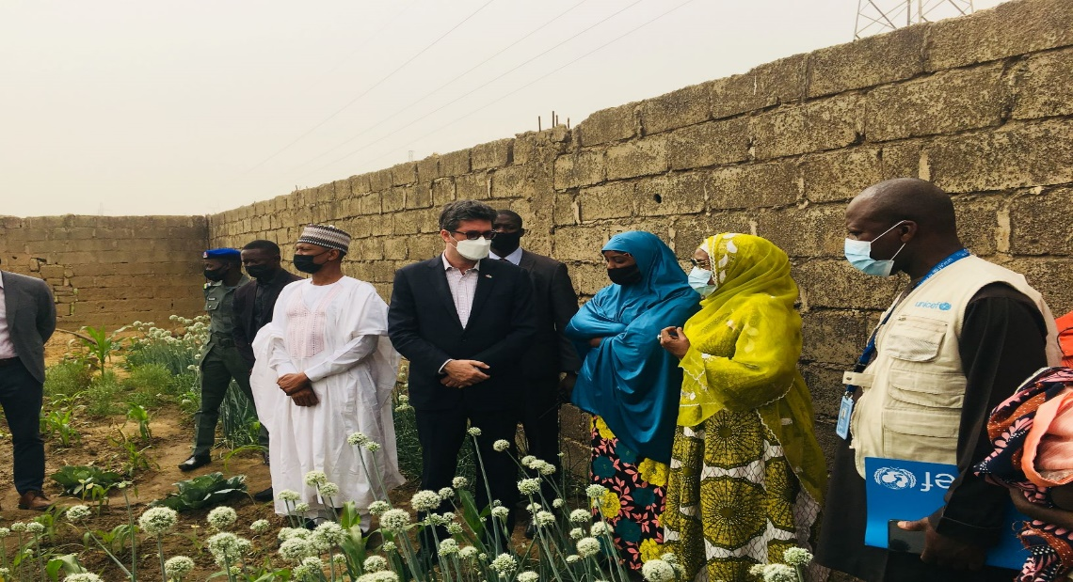

ABUBAKAR RIMI TELEVISION AUTHORITY 2021-Q1 REPORT
INTRODUCTION:
Is one of the government media station and a stake holder in the implementation of all health/nutrition programs as the station that have direct contact with the community has a wider coverage of reaching every corner across the 44 LGAs.
ACTIVITIY CONDUCTED WITHIN THE PERIOD UNDER REVIEW:
- Conduct airing of jingles on breastfeeding and complimentary feeding.

ACHIEVEMENTS:
- Nursing mothers were been educated on importance of breastfeeding and complimentary feeding.
PLAN ACTVITITY:
- At the expiration of the jingles, a proposal had been sent for airing of the same jingles, so that people will comprehend and be familiar with Dietary Diversity and COVID- 19 Pandemic among the children.
- Continue to air news and programs on Nutrition and other health issues in Kano State.
2021 QUARTER-ONE REPORT ON FOOD AND NUTRITION ACTIVITIES IN BASIC EDUCATION SECTOR IN THE STATE (SUBEB)
INTRODUCTION: The state universal basic education board engaging its activities for Food and nutrition as other MDAS through feeding program, agricultural education training program, mobilizing parents by mothers association on how to enhance nutrition in their children daily diets. Also, try as much as possible observe Covid – 19 protocols in the schools across 44 local government of the state.
ACTIVITIES CONDUCTED
Agricultural education training program (AETP) expanded to more 27 schools which make the total schools 54 now. The program is aimed to enhance nutrition and self-reliance among the pupils through different farming as mentioned in 4th quarter 2020 report. Some schools rearing cows, goats and poultry while some school mixed two to three farming e.g cows, goats and poultry, or goats, cows and fishing in which more founds released to schools and sell out the previous products. The total amount from 2018 to 2021 released is N102.6 million from UBEC.
- Two schools also maintain their feeding program excludes one school Shehu Minjibir Boarding Primary School which was closed due to insecurity. The menu remained as its which is full of nutrients.
- Hand Sanitizer also distributed to schools within 44 Local Government last two months (April, 2021).
ACHIEVEMENTS:
- Feeding program in two schools continues with full nutrition in the food.
- Agricultural Education Training Program extended to more 27 schools. And start selling out their products.
- Covid-19 protocol also observing in schools
CHALLENGES:
- No sufficient land for establishment of school garden.
- No funds to expand AETP across the state.
- State committee is not visiting the MDAS to see nutrition activities carrying out.
- Mothers associations need more capacity building for house to house campaign on nutrition.
- Schools need more provision of safety water.
- Feeding program stop by Federal, State and Local Government in our schools due to update screening on number of pupils to be fed.
RECOMMENDATIONS:-
- Itinery should be drawn for visitations of schools and other MDAS and CSO on the nutrition activities.
- Find ways to get more funds for AETP expansion across the state.

- Feeding program in schools should be back immediately after screening, by Federal, State and Local Government.
KANO STATE EMERGENCY MANAGEMENT AGENCY 2021 Q-1
KEY ACTIVITIES OF THE AGENCY:
- To promote the welfare and rehabilitation of disabled persons in the State
DAYS | BREAK-FAST | LUNCH | DINNER
Monday | Koko da wake (Pap & beans) | Rice and beans | Tuwon masara da miyar kuka (baobab soup)
Tuesday | Koko da alala (pap & moi-moi) | Tuwon dawa da miyar kubewa (okro soup) | Spaghetti da macaroni
Wednesday | Koko da wake | Jellof rice | Tuwon masara da miyar kuka
Thursday | Koko da alala | Danwake | Rice and beans
Friday | Koko da wake | Tuwon shinkafa da miyar taushei (pumkin soup) | Tuwon dawa da miyar kubewa
Saturday | Koko da alala | Tuwon masara da miyar karkashi | Jellof rice
Sunday | Koko da wake | Spaghetti da macaroni | Tuwon dawa da miyar kuka
- To run and maintain vocational, reformatory and rehabilitation centers for the training, rehabilitation and re-orientation of the disabled persons
- To market the goods produced by disabled persons while training and after training
MODUS-OPERANDI OF SEMA:
- It has 12 rehabilitation centers spread across the 3 senatorial districts in the State and a vocational training center for the training of disabled persons.
- Inmates are brought into the centers by their relatives through a formal channel or through some government agencies like MoWA, Hisbah, Police etc., and by periodic raiding and evacuation conducted by SEMA
- The inmates are categorized into in-patient and out-patients
- The in-patients are solely taking care off by SEMA in terms of food, medication and other needs.
ACHIEVEMENTS:
- Constant and consistent making available of food and drugs by Government
- Minor and major renovation works across all centers by individuals, NGOs and SEMA
- The growing number of Individuals, communities and NGOs participation
CHALLENGES
- Food items supply by vendors are based on prices that have been pegged long time ago.
- The effect of medication on inmate food consumption pattern.
- High rate of patients discharged returning back due to negligence by relatives and communities in post healing management.
RECOMMENDATIONS
- The need for periodic review of price of food items supply by vendors to reflect reality
- The need to review the current medication on inmates in order to catch up with current development in science and technology or re-rational the food in-take per inmate
- Training and re-training of staff
- Introduction of sanction on relatives who violate post healing management
- Ranking SEMA among critical MDAs in terms of fund releases
- Drug awareness and sensation campaign
- Introduction of punitive measure for relatives who abandoned their patient
- General renovation on all the rehabilitation centers
Public enlighten campaign on the important of community and NGOs involvement
- Paucity of fund
- Increasing number of youths involvement in drug addictions
- Cases of abandonment of patients by their relatives
- Dilapidation of structures
- Low level and low rate of community and NGOs participation relative to the larger population

