UPDATE ON COVID19
  - April 22nd 2020
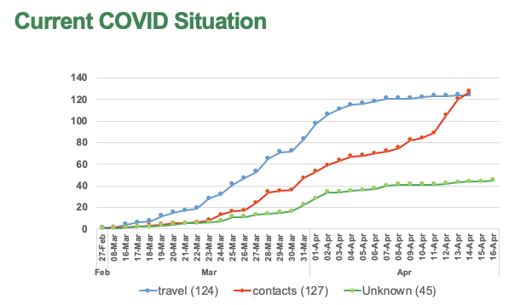
NIGERIA
(Source; NCDC as @ April 8th 2020)
Cases | 782
Discharged | 197
Death | 25
Tests Done | 8,364
States Affected | 25
Highlights
General
- 782 confirmed cases as at 21 April 2020
- 117 new case last 24hrs
- 25 states affected, increasing concern on Kano with 59 cases in less than 2weeks
- 70% of the cases are males; 30% females
- 37% had travel history to hight risk countries
- 34% have history of contact with positive cases
- 61% are in Isolation centres
- 39% are receiving care in homes and other sites
- 42 of the cases are health workers
- Emergency National Council on health meeting held on 21st April (HMH will address the NGF)
Laboratory
- 11 labs optimized, Sokoto in the pipeline
- 8,762 lab tests conducted as @21 April 2020
- Lagos and kano ran out of test kits but is being addressed
- 15,000 viral transport media distributed to states
Contact tracing
- 93% of contacts tracked and exited
- 5 states (Lagos, FCT, Osun, Kaduna and Bauchi) yet to achieve 100% contact tracing
- Imo and Cross Rivers even though they have no cases have 32 and 17 contacts being followed up.
Resource Mobilization
- Second Jack Ma donation has arrived
- Distribution plan for the UN commodities finalized (see attached)

Important Notes
- There is evidence of community transmission in many of the states
- Number of tests increasing but still inadequate
- Health workers are increasingly getting infected; this is of serious concern
- No of cases expected to increase in the coming weeks

Key requests from PTF
- Need for enforcement of State Lockdown, especially interstate travels for non-essential services

- States to procure PPEs a; some local suppliers are now available

- Provide logistics (vehicle, fuelling and allowances) for contact tracing

- Need to accelerate the setting up of isolation centres
  - Level 1 for high risk contacts
  - Level 2 cases with mild to moderate symptoms#
  - Level 3 -Severe cases, will include ICU facilities

#

