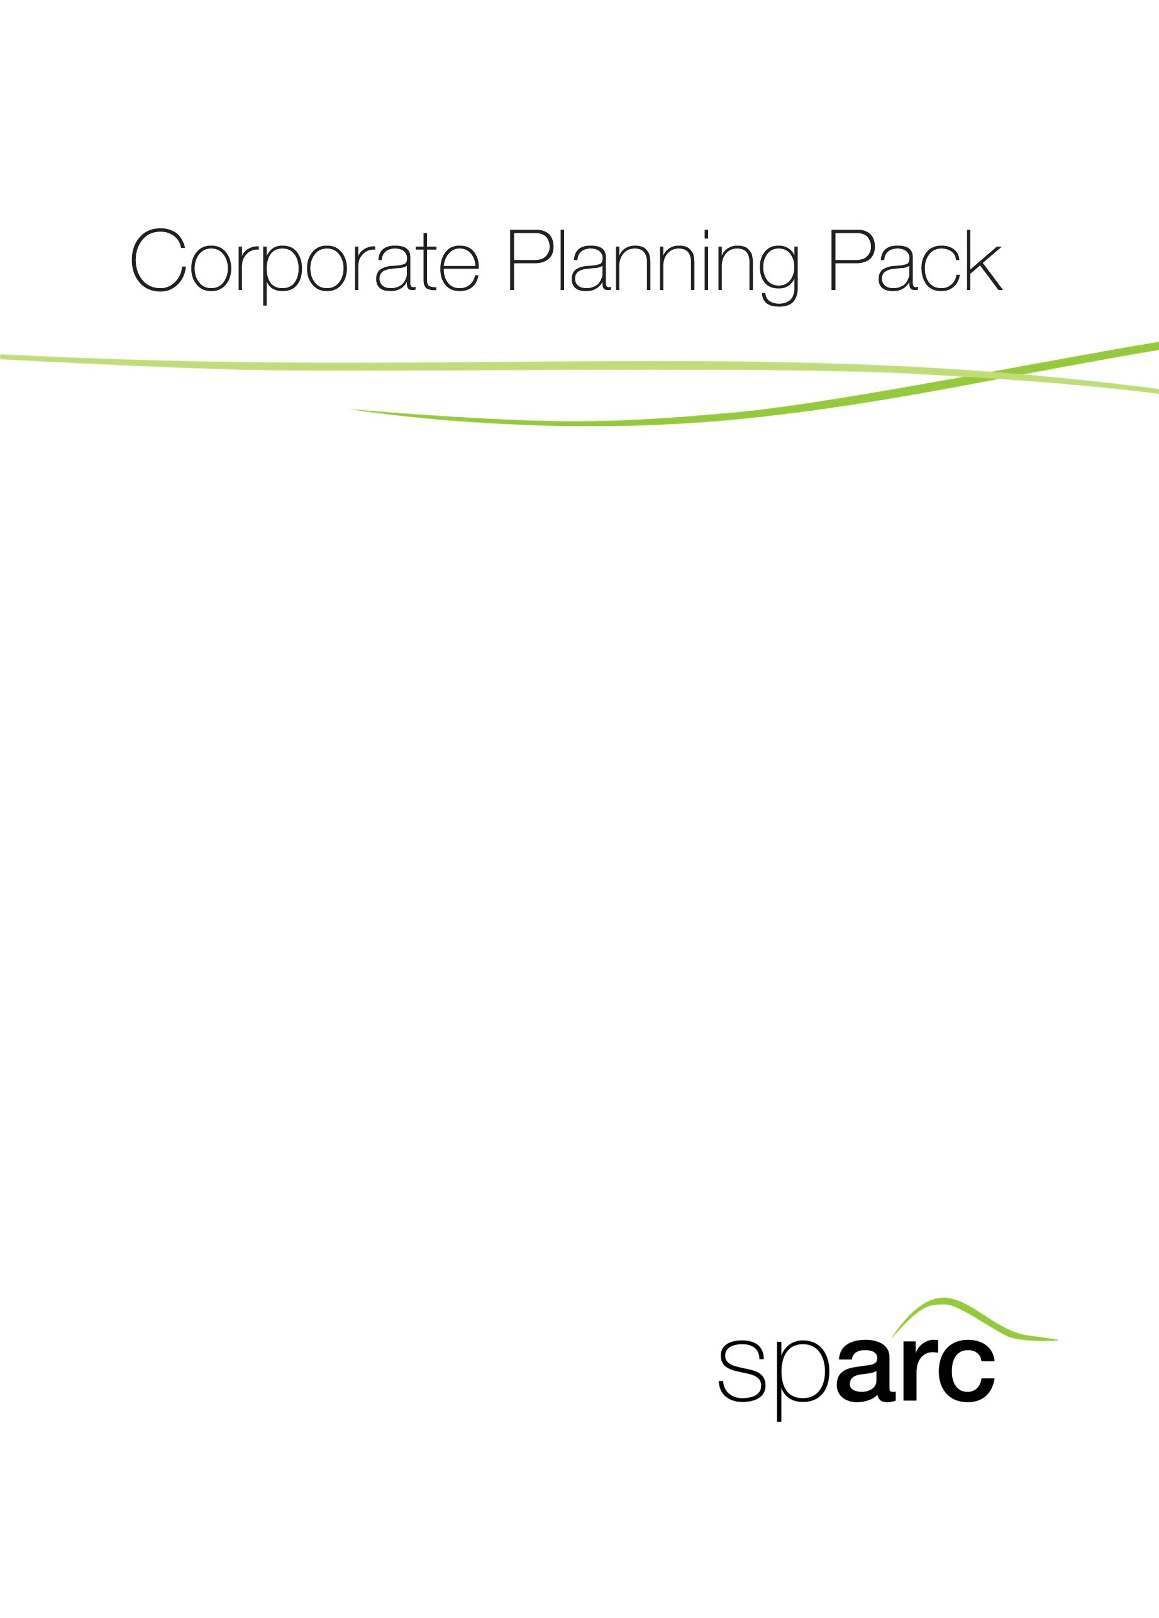
June 2014
Guidance Pack 2013–15
Part 2: Toolkit

Stage 3: Corporate Planning

Process: Functions, Structures and Processes

3b Guidance and Templates to Assist
with Process Review

3b Guidance and Templates to Assist with Process Review

A process specifies the transformation of inputs to outputs. It is a network of connected activities and relationships with the purpose of satisfying customer requirements as illustrated below.

Output

Input
Process

The work performed can be divided into an ordered sequence of activities. Buffers represent storage or waiting points (for example, queues, waiting rooms, etc.) before the next activity. A key issue in process design and analysis is classification of the process activities. This is crucial for identifying waste and inefficiencies in existing processes.

Classifications of Process Activities
Value adding activities are:

- Essential in order to meet customer expectations
- Activities the customer would be willing to pay for
- Involve doing the right things properly, that is:
  - Performing the right activities.
  - Doing them with high efficiency.

Business value adding activities are control activities that do not directly add customer value but are essential to conducting business.

Non-value adding activities are those the user would not be willing to pay for.

The first step in redesigning work processes is to eliminate non-value adding activities. This is often achieved through task or activity consolidation, eliminating unnecessary controls and process complexity.

Templates to help with process mapping and flow-charting are presented below.

Understanding Existing Processes: Template

What is the existing process doing?
How well does it perform?
What are the critical issues that impact the process performance?

Describing a Process using the 5 x ‘W’ and 2 x ‘H’ Framework

Classification | 5w2h questions | - Description
People | Who? | - Who is performing the activity?  - Why is this person doing it?  - Could/should someone else perform the activity?
Subject matter | What? | - What is being done in this activity?  - Can the activity in question be eliminated?
Sequence | When? | - When is the best time to perform this activity?  - Does it have to be done at a certain time or in a specific sequence?
Location | Where? | - Where is this activity carried out?  - Does it have to be done at this location?
Purpose | Why? | - Why is this activity needed?  - Clarify its purpose.
Method | How? | - How is the activity carried out?
Cost | How much? | - How much does it currently cost?

Process Analysis Tools – Process Flowcharts Symbols and Exercises
Flowcharts provide a graphic view of the whole picture – the process from start to finish. The conventional symbols for flowcharts are set out below. The ideal picture is to reduce the steps between operation and decision. The worst thing is to improve something that shouldn’t be done at all.

Symbols to Use in Flowcharts

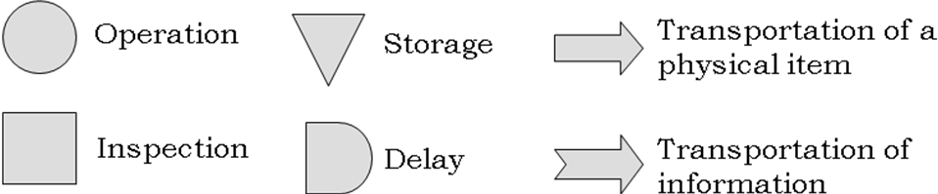

Decision

Illustration: a Simple Flowchart

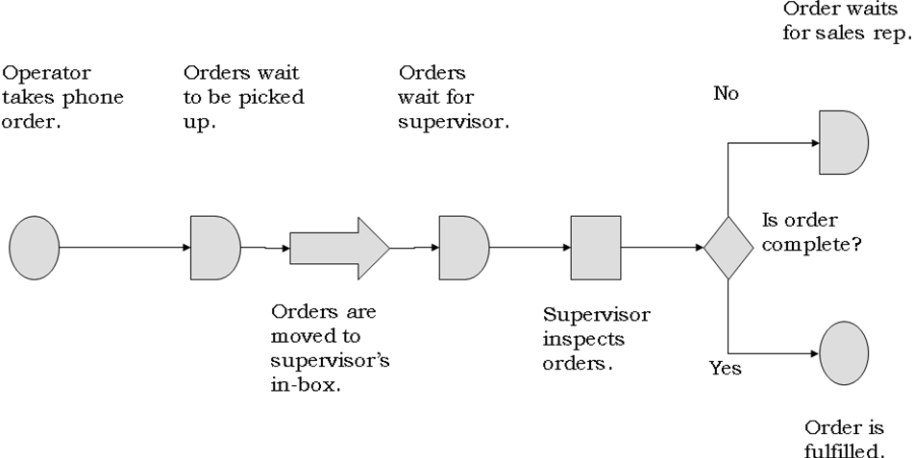

How to Flowchart the Process

- Using the illustrations above as a guide, itemise existing processes for key services and draw a flowchart to depict the business process ‘as is’.
- Highlight value adding activities, business value adding activities and non-value adding activities.

Redesign the process flow – the ‘to be’ recommended picture. Justify your recommendations and identify those processes that you have eliminated or merged.

